Css – important topics concepts

🡪selectors

🡪box model (very important)

🡪borders

🡪margins

🡪padding

🡪display

🡪inline blocks

SELECTORS

🡪simple selectors(dot,hash,simplename)(bases ID ,class, name of the tag)

🡪combinator selector

1. Descendant (space) ---words have space i.e nav ul,nav ul li a ……. (it is like grand children)

2.Child (>) it is like children

3.Adjacent (+) style is applied to only first child

4.General sibling (~) same parent but after specific element ex: apply to last child but not to second.

BOX MODEL

Margin🡪border🡪padding🡪content

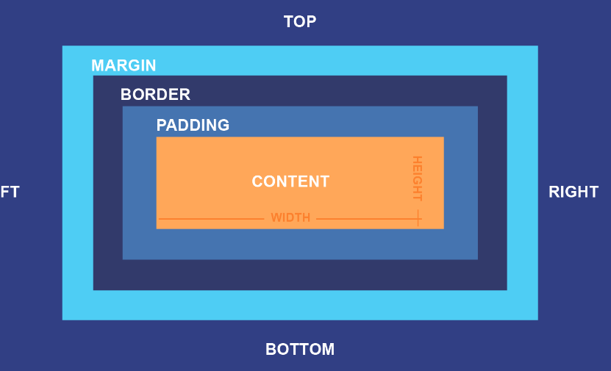

Space between border and content is padding.